**The Nuclear Energy landscape in France**

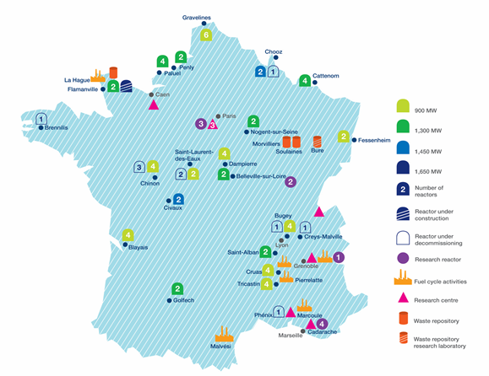

Map of France’s nuclear facilities [(https://cnpp.iaea.org/countryprofiles/France/France.htm)](https://cnpp.iaea.org/countryprofiles/France/France.htm)

With a massive fleet of 58 ‘fission’ powered nuclear power reactors currently in operation, France records the highest percentage of 71.7% of the country's total energy production. Also, France holds the position of being **the world's largest net exporter of electricity.**

The French appeal to nuclear energy dates back to the ground-breaking research conducted by the Nobel Prize laureates Henri Becquerel and Pierre and Marie Curie. However, it was the infamous [oil crisis of 1973](https://en.wikipedia.org/wiki/1973_oil_crisis) that drove the nation's determination to obtain energy independence. As a consequence, the launch of the "[Messmer Plan](https://en.wikipedia.org/wiki/Nuclear_power_in_France" \l "Messmer_Plan)" by the then French Prime Minister Monsieur Pierre Messmer set France on its course to becoming one of the key players in the Nuclear Power industry. By doing so, France has not only ensured lower greenhouse gas emissions but also helped improve the energy trade balance along with stabilizing its domestic energy prices at lower levels and increase the competitiveness of French companies in international markets.

The current fleet of French Pressurized Water Reactors (PWRs) is managed and operated by the country's main electricity generation and distribution company - E[lectricité de France](https://en.wikipedia.org/wiki/Électricité_de_France) (EDF). All these power plants are subjected to a systematic feedback process and a comprehensive periodic safety reassessment process every ten years under the scrutiny of the ASN. Additionally, like several other countries, France follows a **closed nuclear fuel cycle**, wherein it recovers uranium and plutonium by recycling or reprocessing spent fuel. France's national spent fuel policy, its tight legislation and the support of the Nuclear Safety Authority (French: Autorité de sûreté nucléaire**,** ASN) together ensure an efficient and secure energy supply whilst reducing the amount of fuel required for energy generation and also the consequent radioactive waste burden.

However, post-[Fukushima Daiichi accident](https://en.wikipedia.org/wiki/Fukushima_Daiichi_nuclear_disaster) of 2011, France had the massive task of calming the citizens' concerns regarding the safety of their country’s nuclear program. At the same time, despite the vast protests, France stood by nuclear power firmly and enforced stricter safety measures to prepare its nuclear reactors for such extreme natural aggressions. Their outlook on the development and the utilization of nuclear power to reduce CO2 emissions speaks highly of their conviction towards this energy source. Meanwhile, fission isn’t the only source of nuclear energy that is being explored by them. As a part of the European Union, France is a partner with China, India, Japan, Korea, Russia and the USA in the ongoing [ITER](https://en.wikipedia.org/wiki/ITER) (originally the International Thermonuclear Experimental Reactor) megaproject. Currently, under construction in the Southern France region, this 500 MW experimental nuclear fusion reactor is sought to be the world's largest magnetic confinement [plasma physics](https://en.wikipedia.org/wiki/Plasma_physics) experiment that aims to demonstrate the principle of efficient energy production from the fusion process.

To say that nuclear energy is the better energy for our future would not be an over-statement. In-fact, the number of countries seeking nuclear technology to combat climate change problems is increasing. When managed properly, nuclear energy can help reduce greenhouse gas emissions and help save our planet.